Simple Machines

Put the punctuation back into the following writing:

To get a job done you apply a force called an effort the load is the force actually required to do

the job a simple machine can make a task easier in three different ways it can change the size of

a force make things speed up change the direction of a force

Now use Pearson Science 7 p.289 to check your answers.

Changing the size of a force

Describe one simple machine that can change the size of a force ___________________________________

_____________________________________________________________________________________________________________

_____________________________________________________________________________________________________________

Does a jack move a car very far when you need to change a tyre? ___________________________________

On the diagram to the right, draw in the direction the jack moves.

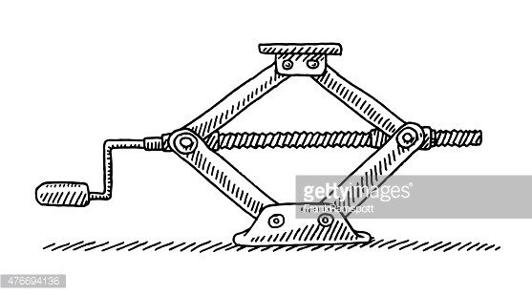
On the diagram draw in how you make the jack move.

Would it be hard to make a car lift up without a jack?

_____________________

Is it hard to make a car lift up with a jack? ___________

Using a car jack makes the work ______________________ to do but you have to wind the handle over

a very___________________ distance.

Making things speed up

Describe one simple machine that can make things speed up ______________________________________

____________________________________________________________________________________________________________

____________________________________________________________________________________________________________
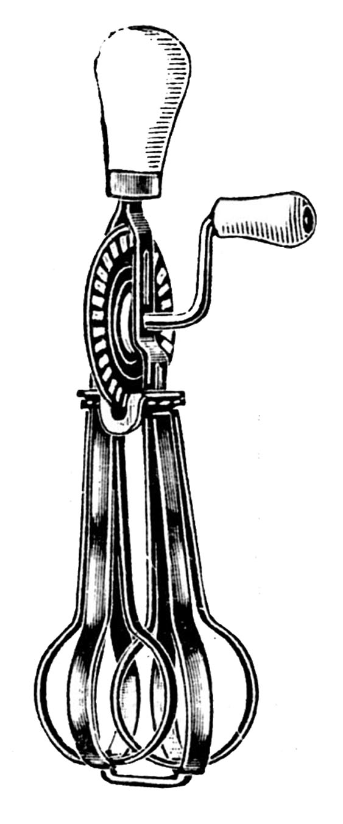
Does the handle of the egg beater turn as fast as the beaters? ______

What is the advantage of the gears in this type of machine? ________

___________________________________________________________________________

___________________________________________________________________________

Could you turn the beaters as fast without the gears? ______________

What are these types of machines called? ___________________________

___________________________________________________________________________

Changing the direction of a force

Describe one simple machine that can change the direction in which a force acts ________________

_____________________________________________________________________________________________________________

_____________________________________________________________________________________________________________
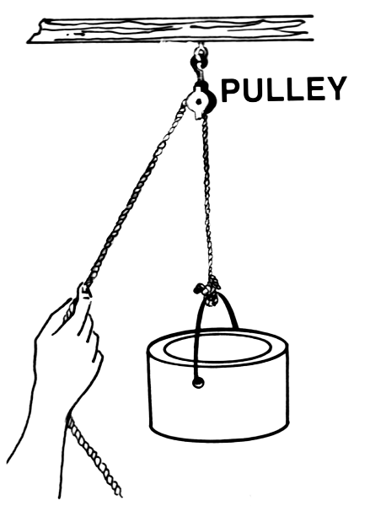
Would it be easy to pull the container up without a pulley? ______

What do you think might happen to the force if you add more

pulleys and change the direction again? ___________________________

_________________________________________________________________________


